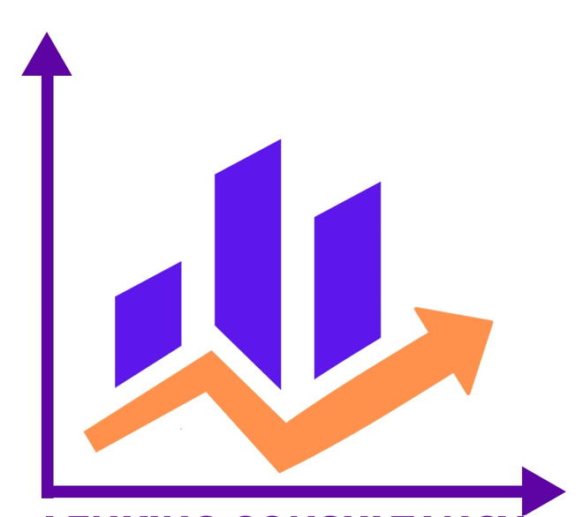

**LENKING CONSULTANCY**

*(Professionalism is our priority)*

**CONTACT:** +254 707 419 630 **Email.** [lenkingconsultancy@gmail.com](mailto:lenkingconsultancy@gmail.com)

**SPSS TRAINING SESSIONS**

**Session 1. Introduction to SPSS**

* Sample Files
* Opening a Data File

**Session** **2. Reading Data.**

* Basic Structure of IBM SPSS Statistics Data Files
* Reading IBM SPSS Statistics Data Files
* Reading Excel Data
* Reading Data from a Database
* Reading Data from a Text File

**Session 3. Using the Data Editor**

* Entering Numeric Data
* Entering String Data
* Defining Data
* Adding Variable Labels
* Changing Variable Type and Format
* Adding Value Labels
* Handling Missing Data
* Missing Values for a Numeric Variable
* Missing Values for a String Variable

**Session 4. Examining Summary Statistics for Individual Variables**

* Level of Measurement
* Summary Measures for Categorical Data
* Charts for Categorical Data
* Summary Measures for Scale Variables
* Histograms for Scale Variables

**Session 5. Creating and editing charts**

* Chart creation basics
* Using the Chart Builder gallery
* Defining variables and statistics
* Adding text
* Creating the chart

**Session 6. Working with Output**

* Using the Viewer
* Using the Pivot Table Editor
* Accessing Output Definitions
* Pivoting Tables
* Creating and Displaying Layers
* Editing Tables
* Hiding Rows and Columns
* Changing Data Display Formats
* Changing the Default Table Formats
* Customizing the Initial Display Settings
* Displaying Variable and Value Labels
* Using Results in Other Applications
* Pasting Results as Word Tables
* Pasting Results as Text
* Exporting Results to Microsoft Word, PowerPoint, and Excel Files
* Exporting Results to PDF
* Exporting Results to HTML

**Session 7. Working with Syntax**

* Pasting Syntax
* Editing Syntax
* Opening and Running a Syntax File

**Session 9. Sorting and Selecting Data**

* Sorting Data
* Split-File Processing
* Sorting Cases for Split-File Processing
* Turning Split-File Processing On and Off

**Session** **10. Power Analysis**

* Means
* Proportions
* Correlations
* Regression

**Session 11. Frequencies**

* Frequencies Statistics
* Frequencies Charts
* Frequencies Format

**Session 12.** **Explore**

* Explore Statistics
* Explore Plots
* Explore Options

**Session 13. Crosstabs**

* Crosstabs layers
* Crosstabs clustered bar charts
* Crosstabs displaying layer variables in table layers
* Crosstabs statistics
* Crosstabs cell display
* Crosstabs table format
* Summarize Statistics
* Means

**Session 14.** **Proportions**

* Proportions introduction
* One-Sample Proportions
* Paired-Samples Proportions
* Independent-Samples Proportions

**Session 15. T Tests**

* Independent-Samples T Test
* Paired-Samples T Test
* One-Sample T Test

**Session 16. One-Way ANOVA**

* One-Way ANOVA Contrasts
* One-Way ANOVA Post Hoc Tests
* One-Way ANOVA Options

**Session 17.** **GLM Univariate Analysis**

* GLM Mode
* GLM Contrasts
* GLM Profile Plots
* GLM Post Hoc Comparisons
* GLM Save
* GLM Estimated Marginal Means

**Session 18.** **Bivariate Correlations**

* Bivariate Correlations Options
* Bivariate Correlations Confidence Interval
* CORRELATIONS and NONPAR CORR Command Additional Features

**Session 19.** **Partial Correlations**

* Partial Correlations Options
* PARTIAL CORR Command Additional Features

**Session 20.** **Linear models**

* To obtain a linear mode
* Objectives
* Basics
* Model Selection
* Model Options
* Model Summary
* Automatic Data Preparation
* Predictor Importance
* Predicted By Observed
* Residuals
* Outliers
* Effects
* Coefficients
* Estimated Means
* Model Building Summary

**Session 21.** **Linear Regression**

* Linear Regression Variable Selection Methods
* Linear Regression Set Rule
* Linear Regression Plots
* Linear Regression: Saving New Variables
* Linear Regression Statistics
* Linear Regression Options

**Session 22.** **Ordinal Regression**

* Ordinal Regression Options
* Ordinal Regression Output
* Ordinal Regression Location Model
* Ordinal Regression Scale Model

**Session 23.** **Discriminant Analysis**

* Discriminant Analysis Define Range
* Discriminant Analysis Select Cases
* Discriminant Analysis Statistics
* Discriminant Analysis Stepwise Method
* Discriminant Analysis Classification
* Discriminant Analysis Save

**Session 24.** **Factor Analysis**

* Factor Analysis Select Cases
* Factor Analysis Descriptives
* Factor Analysis Extraction
* Factor Analysis Rotation
* Factor Analysis Scores
* Factor Analysis Options

**Session 25.** **Hierarchical Cluster Analysis**

* Hierarchical Cluster Analysis Method
* Hierarchical Cluster Analysis Statistics
* Hierarchical Cluster Analysis Plots
* Hierarchical Cluster Analysis Save New Variables
* CLUSTER Command Syntax Additional Features

**Session 26.** **Nonparametric Tests**

* One-Sample Nonparametric Tests
* Independent-Samples Nonparametric Tests
* Related-Samples Nonparametric Tests
* Model View
* NPTESTS command additional features
* Legacy Dialogs

**Session 27.** **Reliability Analysis**

* Reliability Analysis: Statistics